Utilitarian Distribution of Scarce Surgical Capacity During the COVID-19 Crisis and Beyond: A Comparative Modelling Study

Benjamin Gravesteijn* (0000-0001-8096-5803)1,2, Eline Krijkamp* (0000-0003-3970-2206)3,5, Jan Busschbach (0000-0002-8602-0381)4,5, Geert Geleijnse (0000-0002-4718-0032)1, Isabel Retel Helmrich (0000-0001-5257-395X)2, Sophie Bruinsma (0000-0003-3634-9899)6, Céline van Lint (0000-0002-7929-7622)6, Ernest van Veen (0000-0002-5495-3996)2,7, Jan van Saase (0000-0003-2874-6667) 8, Hester Lingsma (0000-0003-2063-9533)2, Rob Baatenburg de Jong (0000-0001-7236-264X)1, and the Value Based OR team collaborators**

*Both authors contributed equally

Author affiliations - Request all authors to check the affiliation + ORCID ID

1) Department of Otorhinolaryngology (ENT); 2) Department of Public Health; 3) Department of Epidemiology; 4) Department of Medical Psychology; 5) Netherlands Institute for Health Sciences; 6) Department of Quality and Patient Care; 7) Department of Intensive Care; 8) Department of Internal Medicine - Erasmus University Medical Center, Rotterdam, the Netherlands.

## Purpose

COVID-19 has put unprecedented pressure on health care systems worldwide. This has led to a reduction of the health care capacity available for non-emergency surgical interventions. As a result, an accumulating number of patients is waiting for vital surgeries and societies face dilemmas about prioritization of patients. Therefore, our objective was to develop a decision model to estimate the effects of delay of surgical interventions on health and quality of life that can be used for prioritization.

Methods

A cohort state-transition model was developed to simulate long-term implications of delaying surgery. The model was applied to 34 semi-elective (not necessarily performed within 3 days, but ideally performed within 3 weeks) surgeries on adults commonly performed in one of the eight Dutch academic hospitals. We compared scenarios of delaying surgery from two weeks up to one year (with 10-week intervals) and no surgery at all. Model parameters were based on Dutch and American registries, literature, and the global burden of disease study by the World Health Organization. For each surgical indication, we estimated the average expected Quality-Adjusted Life-Years (QALYs) for the different scenarios. Urgency was defined as expected health loss due to surgical delay, expressed in QALY loss per month (QALY/month). A probabilistic sensitivity analysis was performed to incorporate parameter uncertainty in the model estimates.

## Results

The maximum QALYs gained varied between procedures, from 0.54 QALYs (95%-CI: 0.48–0.61) for resection of high-grade glioma to 10.3 QALYs (8.7-11.9) for kidney transplantation. The three most urgent interventions were surgically repairing an abdominal aorta aneurysm (-0.11 QALY/month, -0.13 – -0.09), pacemaker implantation (-0.11 QALY/month, -0.22 - -0.04), and resecting a cholangiocarcinoma (-0.09 QALY/month, -0.12 - -0.06). The three least urgent interventions were the placing of a shunt for dialysis (-0.01 QALY/month, -0.01 – -0.005), resecting thyroid carcinoma (-0.01 QALY/month, -0.02 - -0.01), and resecting mild salivary gland carcinoma (-0.01 QALY/month, -0.03 - -0.01).

## Conclusion

Expected health loss due to surgical delay could *reliably* be quantified with our decision model and can guide prioritization of surgical care from a utilitarian perspective (i.e. minimizing health loss on population level) in times of scarcity (e.g. due to COVID-19). Placing this tool in the context of different ethical perspectives and combining it with capacity management tools is key to achieve large-scale implementation.

|  |
| --- |
|  |
| ***Figure 1: The average loss of QALYs and LYs per month of delay for the investigated surgical interventions. These estimates are based on the results from the simulated scenario of surgery delay of 52 weeks.*** *The dots are the mean estimates. The bars represent the 95% confidence intervals.* Abbreviations: QALY: Quality-Adjusted Life-Years, LY: Life-years; *AAA: aneurysm of the abdominal aorta; ASD: atrial septum defect; AP: angina pectoris; CABG: coronary artery bypass graft; ESHF: end-stage heart failure; ESLD: end-stage liver disease; ESRD: end-stage renal disease (kidney transplantation); EVAR: endovascular aortic repair; ca.: carcinoma; HCC: hepatocellular carcinoma; HIPEC: hyperthermic intraperitoneal chemotherapy; NSCLC: non-small cell lung carcinoma; UUT: upper urinary track; VATS: video assisted thoracoscopic surgery; PAD: peripheral arterial disease; PCI: percutaneous coronary intervention.* |

## Extra figures for Manuscript

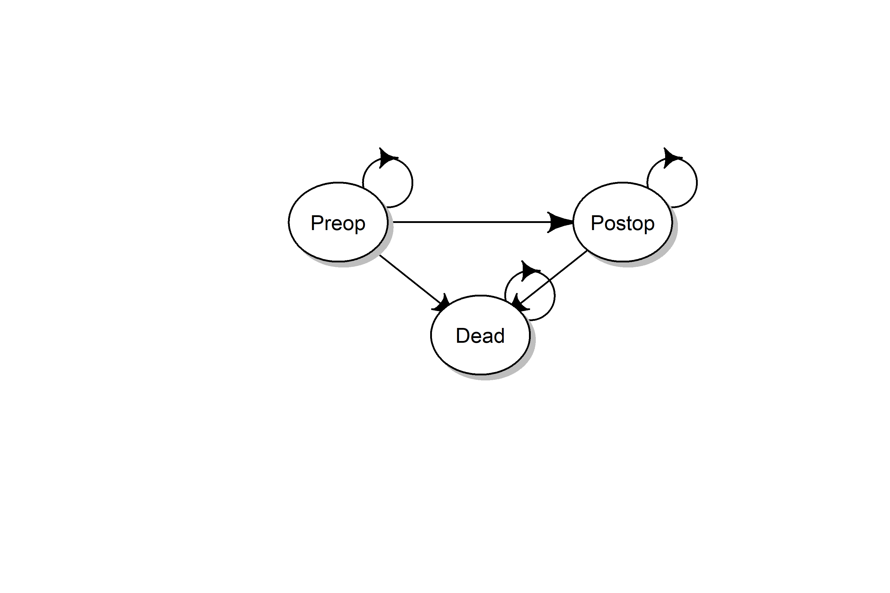

Figure 1, state-transition diagram of the model. The model is a Markov model consisting of three states: a preoperative state (Preop), a postoperative state (Postop), and the absorbing state Dead. All patient eligible of semi-elective surgery start in the Preop health states. From the Preop states they can die, transition to dead, or continue to wait for their surgery. At the time of surgery, which is determined by the scenario analysis, all individuals still alive in the Preop health state transition to the Postop health state. The remaining lifetime the cohort is followed. They can die, transition for the Postop state to dead or stay alive in the Postop health state.

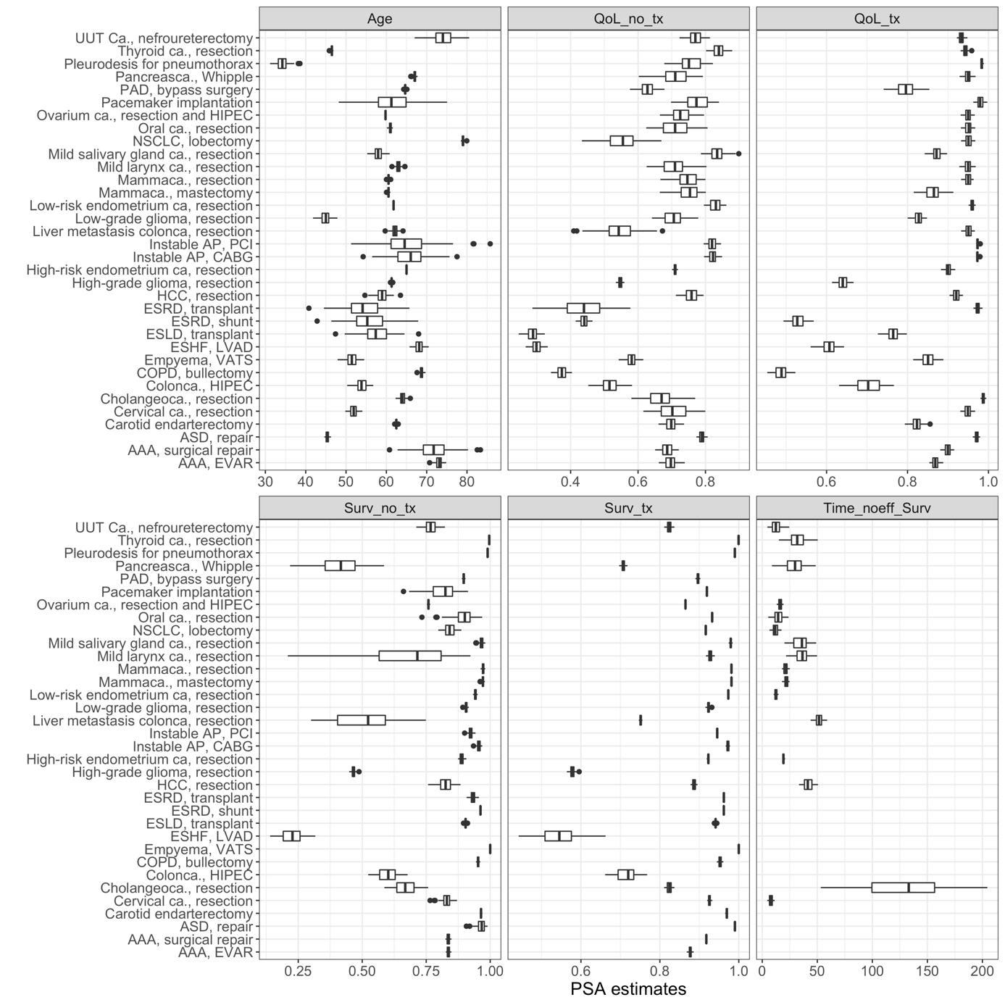

Figure 2, input parameters for the model. For a full list of input parameters per disease and source, see appendix A. Qol_no_tx: Quality of Life without treatment; QoL_tx: quality of life with treatment; Surv_no_tx: 1-year survival probability without treatment; Surv_tx: 1-year survival probability with treatment; Time_noeff_surv: days until no treatment is effective. ESRD: end-stage renal disease; ASD: atrial septum defect; VATS: video assisted thoracoscopic surgery; ESLD: end-stage liver disease; AAA: aneurysm of the abdominal aorta; AP: angina pectoris; CABG: coronary artery bypass graft; PCI: percutaneous coronary intervention; NSCLC: non-small cell lung carcinoma; EVAR: endovascular aortic repair; ca.: carcinoma; PAD: peripheral arterial disease; HCC: hepatocellular carcinoma; ESHF: end-stage heart failure; HIPEC: hyperthermic intraperitoneal chemotherapy.

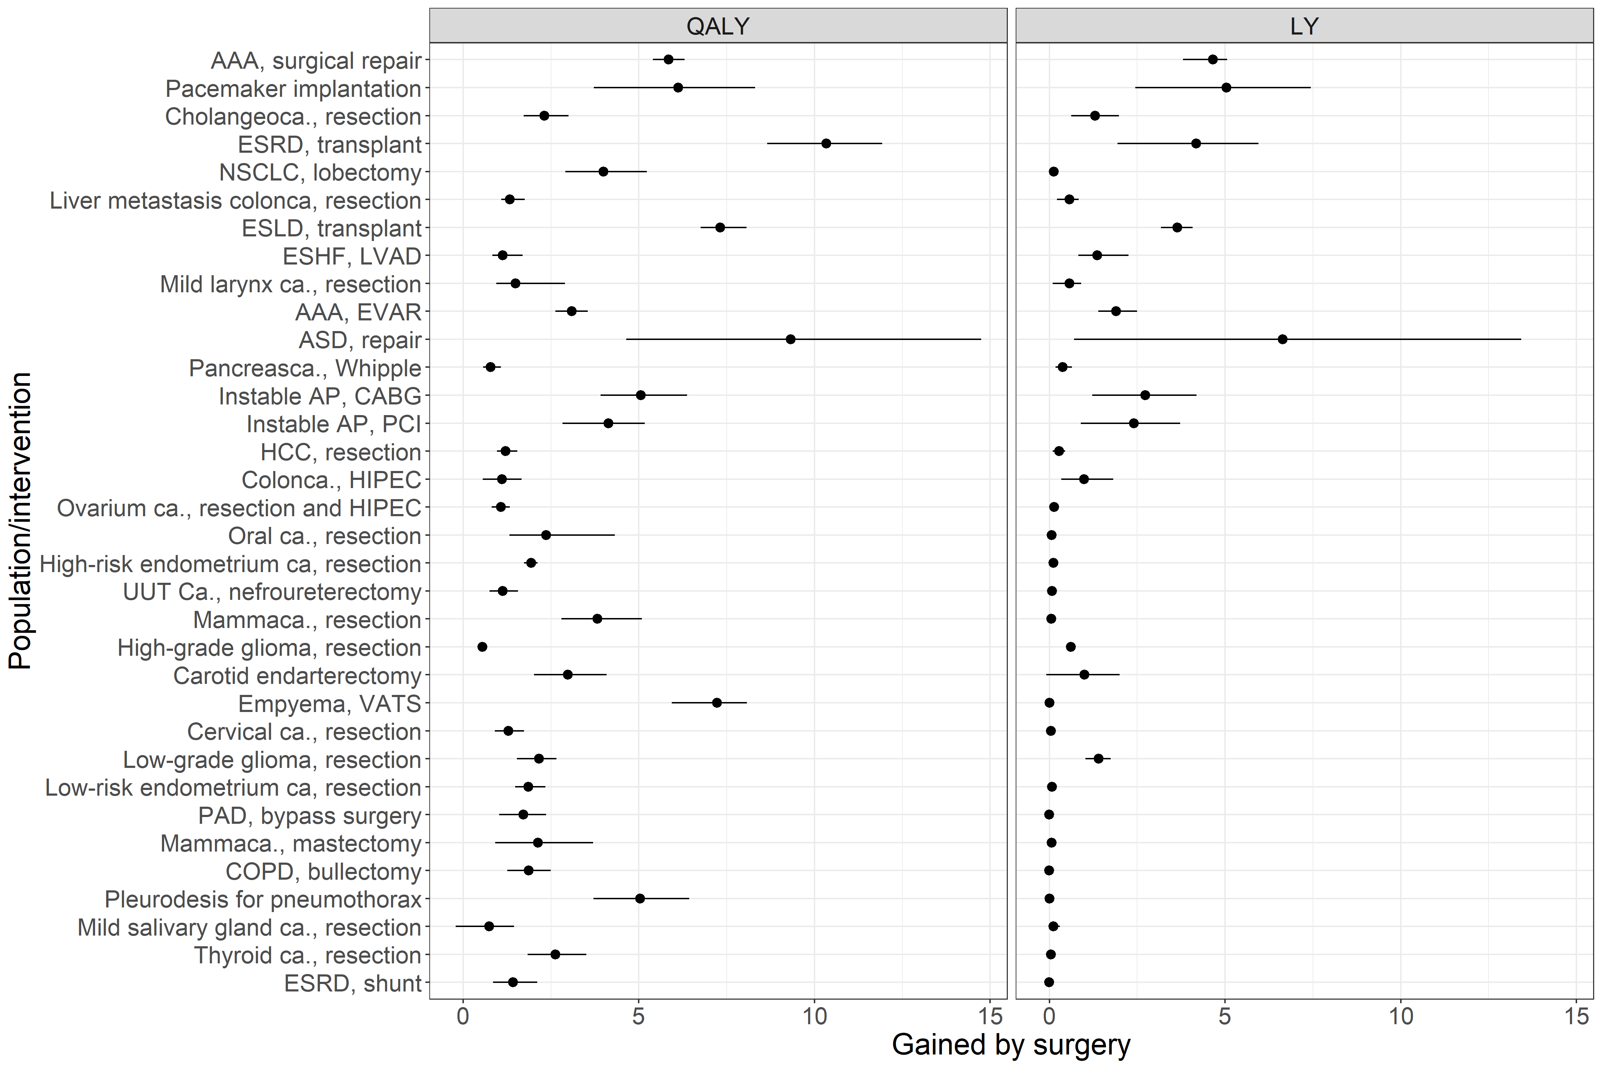

Figure 3, the maximum expected QALYs and LYs per intervention, in descending order of urgency (see figure 4). The estimates and 95% confidence intervals are shown. The model output for no surgery was subtracted from the model output for a delay of 2 weeks. The actual data are presented in Appendix B. ESRD: end-stage renal disease; ASD: atrial septum defect; VATS: video assisted thoracoscopic surgery; ESLD: end-stage liver disease; AAA: aneurysm of the abdominal aorta; AP: angina pectoris; CABG: coronary artery bypass graft; PCI: percutaneous coronary intervention; NSCLC: non-small cell lung carcinoma; EVAR: endovascular aortic repair; ca.: carcinoma; PAD: peripheral arterial disease; HCC: hepatocellular carcinoma; ESHF: end-stage heart failure; HIPEC: hyperthermic intraperitoneal chemotherapy.